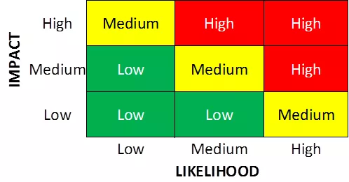

Risk, source, impact, likelihood, level, mitigation

| Risk | Source | Impact | Likelihood | Level | Mitigation |
| --- | --- | --- | --- | --- | --- |
| Credential compromise | Default credentials | 2 - Medium | 1 - Low | 1.5 - Low | Change default credentials to complex credentials |
| Data Leak |  |  |  |  |  |
| Power outage |  |  |  |  |  |
| Phishing |  |  |  |  |  |
| Installed malware |  |  |  |  |  |